Database 2017-1

Prof. Minsoo Lee

**Movie Information Management**

**Database**

**TEAM 13**

1198057 왕소정

1346021 이란희

1346002 김이정

1502121 한수진

IES16515 Quentin Lexert

IES16731 Keyu Lin

Submit Date: 2017.06.01

**Contents**

1. ER Diagram
2. Schema Diagram
3. Class & Method explanation
4. Main Class
5. 17 Requirements
6. Team Responsibility
7. SQL Scripts
8. Java Codes
9. ER Diagram

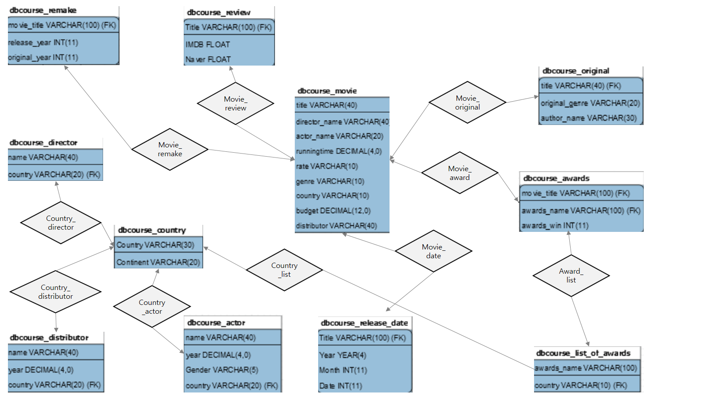

1. Schema Diagram

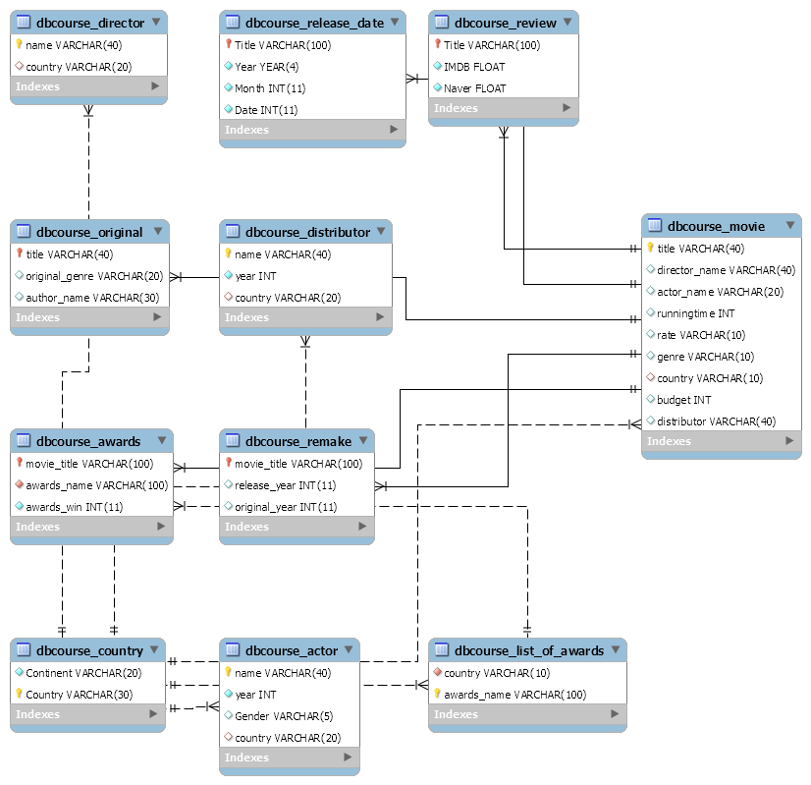

1. Class&Method explanation

Class: team13 is only and main class.

Method:

1. Main

Main Class name: team13

How to run:

Select Menu

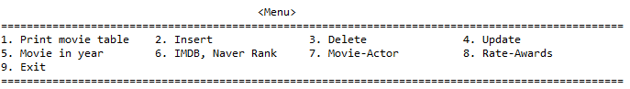

1. Print current table
2. Insert Movie record and if want insert more information insert into Review, release_date, Original, Awards, Remake table.
3. Delete Movie record
4. Update this month naver review.
5. What movie is in year period. (QUREY)
6. IMDB
7. Enter movie, then show Is Movie contry and Actor country is same?
8. Enter review value. Judge if the moive which was reviewed more than 4, and won any awards.

Connection:

1. 17 Requirements
2. Should have at least 10 tables with total of at least 30 columns

* 11 tables: dbcourse_movie, dbcourse_director, dbcourse_original, dbcourse_awards, dbcourse_country, dbcourse_release_date, dbcourse_distributor, dbcourse_remake, dbcourse_actor, dbcourse_review, list_of_awards

1. Should have at least 50 records inserted for initialization
2. Team responsibility

|  |  |  |  |  |  |  |
| --- | --- | --- | --- | --- | --- | --- |
| Member | SQL | Java code | Report | Presentation | Demo video | Etc |
| Sujin Han | -Create&Insert Movie, Original table | -Update |  |  |  |  |
| Quentin | - | - Insert extra information |  |  |  |  |
| Keyu |  | -Query |  |  |  |  |
| Sojeong Wang | Create&Insert Remake, Award, List_of_Awards table | -Print method |  |  |  |  |
| Eeejeong Kim | Create&Insert Release_Date, Country, Review table | -Insert Movie record |  |  |  |  |
| Ranhee Lee | Create&Insert Director, Actor, Distributor table | -Delete Movie record and other tables |  |  |  |  |

1. SQL Scripts

1) creadb.sql

1. Create database Team13;
2. #Country Creation & initial Insertion- Eeejeong Kim
3. CREATE TABLE Team13.DBCOURSE_Country (
4. Continent varchar(20) not null,
5. Country varchar(30) primary key);
6. insert into Team13.DBCOURSE_Country
7. values
8. ('Asia', 'India'),
9. ('Asia', 'Korea'),
10. ('Asia', 'China'),
11. ('Asia', 'Japan'),
12. ('Europe', 'France'),
13. ('Europe', 'UK'),
14. ('Europe', 'Germany'),
15. ('Europe', 'Sweden'),
16. ('Europe', 'Italy'),
17. ('North America', 'USA'),
18. ('North America', 'Canada'),
19. ('South America', 'Brazil'),
20. ('South America', 'Argentina'),
21. ('Africa', 'Republic of South Africa'),
22. ('Austrailia', 'Austrailia');
23. #Movie Creation & Initial insertion - Sujin Han
24. create table Team13.DBCOURSE_Movie(
25. title varchar(40) primary key,
26. director_name varchar(40),
27. actor_name varchar(20),
28. runningtime numeric(4,0),
29. rate varchar(10),
30. genre varchar(10),
31. country varchar(10),
32. budget numeric(12,0),
33. distributor varchar(40),
34. foreign key (country) references Team13.DBCOURSE_Country (country));
35. insert into Team13.DBCOURSE_Movie values('The Shawshank Redemption','Frank Darabont', 'Tim Robbins', 142, '15','Crime','USA',25000000 ,'PolyGram Film International');
36. insert into Team13.DBCOURSE_Movie values('Harry Potter and the Sorcerers Stone','Chris Columbus', 'Daniel Radcliffe', 152, 'ALL', 'Adventure','UK',125000000, 'Waner Bros');
37. insert into Team13.DBCOURSE_Movie values('Inception', 'Christopher Nolan','Leonardo DiCaprio',148,'12','Action','USA',160000000,'Warner Bros');
38. insert into Team13.DBCOURSE_Movie values('The Matrix','The Wachowski Brothers','Keanu Reeves',136,'12','Action','USA',63000000,'Warner Bros');
39. insert into Team13.DBCOURSE_Movie values('Toy Story','John Lasseter','Tom Hanks',81,'ALL', 'Animation','USA',30000000,'World Disney Company');
40. insert into Team13.DBCOURSE_Movie values('The Dark Knight','Christopher Nolan','Christian Bale',152,'15','Action','USA',185000000,'Warner Bros');
41. insert into Team13.DBCOURSE_Movie values('Amelie','Jean-Pierre Jeunet','Audrey Tautou',122,'18','Romance','France',13000000,'Columbia Tristar Pictures');
42. insert into Team13.DBCOURSE_Movie values('Carol','Todd Haynes','Cate Blanchett',118,'18','Drama','UK',11800000,'Weinstein Company, The');
43. insert into Team13.DBCOURSE_Movie values('Beauty and the Beast','Bill Condon','Emma Watson',129,'ALL','Romance','USA',160000000,'World Disney Company');
44. insert into Team13.DBCOURSE_Movie values('Three idiots','Rajkumar Hirani','Aamir Khan',170,'12','Comedy','India',8600000,'Reliance Big Pictures');
45. insert into Team13.DBCOURSE_Movie values('Resident Evil:Retribution','Paul W.S. Anderson','Milla Jovovich',96,'18','Action','Germany',65000000,'Constantin Film');
46. insert into Team13.DBCOURSE_Movie values('Let me in', 'Matt reeves','Kodi Smit-McPhee',116,'15','Drama','UK',20000000,'Lotte entertainment');
47. insert into Team13.DBCOURSE_Movie values('Leon','Aamir Khan','Jean Reno',110,'18','Crime','France',210000000,'Columbia Pictures');
48. insert into Team13.DBCOURSE_Movie values('Let The Right One In','Tomas Alfredson','Kare Hedebrant',115,'15','Drama','UK',4000000,'Gu An');
49. insert into Team13.DBCOURSE_Movie values('Taken','Pierre Morel','Liam Neeson',93,'18','Action','Sweden',25000000,'20th Century Fox');
50. insert into Team13.DBCOURSE_Movie values('The Da Vinci Code','Ron Howard','Tom Hanks',149,'15','Mystery','France',125000000,'Sony Pictures');
51. insert into Team13.DBCOURSE_Movie values('Old boy','Chan-wook Park','Min-sik Choi',120,'18','Drama','Korea',3000000,'CJ Entertainment');
52. insert into Team13.DBCOURSE_Movie values('Howls moving castle','Hayao Miyazaki','Chieko Baisho',119,'ALL','Animation','Japan',24000000,'ISU C&E');
53. insert into Team13.DBCOURSE_Movie values('Lust, Caution','Ang Lee','Tony Chiu-Wai Leung',157,'18','Drama','China',15000000,'CJ Entertainment');
54. insert into Team13.DBCOURSE_Movie values('PK','Rajkumar Hirani','Aamir Khan',129,'15','Comedy','India',3000000,'UTV Motion Pictures');
55. insert into Team13.DBCOURSE_Movie values('Faa yeung nin wa','Kar-Wai Wong','Tony Chiu-Wai Leung',98,'15','Drama','China',2000000,'GoodTime Entertainment');
56. #Original Creation & Initial insertion - Sujin Han
57. create table Team13.DBCOURSE_original(
58. title varchar(40) primary key,
59. original_genre varchar(20),
60. author_name varchar(30),
61. foreign key (Title) references Team13.DBCOURSE_Movie (title) on delete cascade);
62. insert into Team13.DBCOURSE_original values('Harry Potter and the Sorcerers Stone','Novel','Joan K. Rowling ');
63. insert into Team13.DBCOURSE_original values('The Dark Knight','Comic Book','Bob Kane');
64. insert into Team13.DBCOURSE_original values('Beauty and the Beast','Novel', 'L.Beaumont');
65. insert into Team13.DBCOURSE_original values('Resident Evil:Retribution','Game','Capcom');
66. insert into Team13.DBCOURSE_original values('Let me in','Book','John Ajvide Lindqvist');
67. insert into Team13.DBCOURSE_original values('Let The Right One In','Novel','John Ajvide Lindqvist');
68. insert into Team13.DBCOURSE_original values('The Da Vinci Code','Novel','Dan Brown');
69. insert into Team13.DBCOURSE_original values('Lust, Caution','Novel', 'Zhang Ailing');
70. #Review Creation & initial Insertion- Eeejeong Kim
71. CREATE TABLE Team13.DBCOURSE_Review (
72. Title varchar(100) primary key,
73. IMDB float(5) not null,
74. Naver float(5) not null,
75. foreign key (Title) references Team13.DBCOURSE_Movie (title) on delete cascade);
76. insert into Team13.DBCOURSE_Review
77. values
78. ('The Shawshank Redemption', 9.3, 9.4),
79. ('Harry Potter and the Sorcerers Stone', 7.5, 9.2),
80. ('Inception', 8.8, 9.21),
81. ('The Matrix', 8.7, 9.38),
82. ('Toy Story', 8.3, 9.3),
83. ('The Dark Knight', 9, 9.32),
84. ('Amelie', 8.4, 8.87),
85. ('Carol', 7.2, 8.53),
86. ('Beauty and the Beast', 7.7, 8.83),
87. ('Three idiots', 8.4, 9.34),
88. ('Resident Evil:Retribution', 5.4, 5.85),
89. ('Let me in', 7.2, 8.04),
90. ('Leon', 8.6, 9.38),
91. ('Let The Right One In', 8, 8.51),
92. ('Taken', 7.8, 9.2),
93. ('The Da Vinci Code', 6.6, 7.36),
94. ('Old boy', 8.4, 9.05),
95. ('Howls moving castle', 8.2, 9.1),
96. ('Lust, Caution', 7.6, 8.52),
97. ('PK', 8.2, 9.04),
98. ('Faa yeung nin wa', 8.1, 8.86);
99. #Release_Date Creation & initial Insertion- Eeejeong Kim
100. CREATE TABLE Team13.DBCOURSE_Release_Date (
101. Title varchar(100) primary key,
102. Year year not null,
103. Month int not null,
104. Date int not null,
105. foreign key (Title) references Team13.DBCOURSE_Movie (title) on delete cascade);
106. insert into Team13.DBCOURSE_Release_Date
107. values
108. ('The Shawshank Redemption', 1994, 1, 28),
109. ('Harry Potter and the Sorcerers Stone', 2001, 12, 14),
110. ('Inception', 2010, 7, 21),
111. ('The Matrix', 1999, 5, 15),
112. ('Toy Story', 1995, 12, 23),
113. ('The Dark Knight', 2008, 8, 6),
114. ('Amelie', 2001, 10, 19),
115. ('Carol', 2016, 2, 4),
116. ('Beauty and the Beast', 2017, 3, 16),
117. ('Three idiots', 2011, 8, 17),
118. ('Resident Evil:Retribution', 2012, 9, 14),
119. ('Let me in', 2010, 11, 18),
120. ('Leon', 1995, 2, 18),
121. ('Let The Right One In', 2008, 11, 13),
122. ('Taken', 2008, 4, 10),
123. ('The Da Vinci Code', 2006, 5, 18),
124. ('Old boy', 2003, 11, 21),
125. ('Howls moving castle', 2004, 12, 24),
126. ('Lust, Caution', 2007, 11, 8),
127. ('PK', 2015, 9, 3),
128. ('Faa yeung nin wa', 2000, 10, 21);
130. #Distributor Creation & Insertion - Ranhee Lee
131. create table Team13.DBCOURSE_Distributor(
132. name varchar(40) primary key,
133. year numeric(4,0) not null,
134. country varchar(20),
135. foreign key (country) references Team13.DBCOURSE_country (country));
137. #Director Creation & Insertion - Ranhee Lee
138. create table Team13.DBCOURSE_Director(
139. name varchar(40) primary key,
140. country varchar(20),
141. foreign key (country) references Team13.DBCOURSE_country (country));
142. #Actor Creation & Insertion - Ranhee Lee
143. create table Team13.DBCOURSE_Actor(
144. name varchar(40) primary key,
145. year numeric(4,0) not null,
146. Gender varchar(5),
147. country varchar(20),
148. foreign key (country) references Team13.DBCOURSE_country (country));
150. INSERT INTO Team13.DBCOURSE_Distributor VALUES ('PolyGram Film International',1980,'UK');
151. INSERT INTO Team13.DBCOURSE_Distributor VALUES ('Warner Bros',1923,'USA');
152. INSERT INTO Team13.DBCOURSE_Distributor VALUES ('World Disney Company',1923,'USA');
153. INSERT INTO Team13.DBCOURSE_Distributor VALUES ('Columbia Tristar Pictures',1998,'USA');
154. INSERT INTO Team13.DBCOURSE_Distributor VALUES ('The Weinstein Company',1979,'USA');
155. INSERT INTO Team13.DBCOURSE_Distributor VALUES ('Reliance Big Pictures',2005,'India');
156. INSERT INTO Team13.DBCOURSE_Distributor VALUES ('Constantin Film',1979,'Germany');
157. INSERT INTO Team13.DBCOURSE_Distributor VALUES ('Lotte entertainment',2003,'Korea');
158. INSERT INTO Team13.DBCOURSE_Distributor VALUES ('Columbia Pictures',1924,'USA');
159. INSERT INTO Team13.DBCOURSE_Distributor VALUES ('Gu An',2008,'Korea');
160. INSERT INTO Team13.DBCOURSE_Distributor VALUES ('20th Century Fox',1935,'USA');
161. INSERT INTO Team13.DBCOURSE_Distributor VALUES ('Sony Pictures',1991,'USA');
162. INSERT INTO Team13.DBCOURSE_Distributor VALUES ('CJ Entertainment',2006,'Korea');
163. INSERT INTO Team13.DBCOURSE_Distributor VALUES ('ISU C&E',2014,'Korea');
164. INSERT INTO Team13.DBCOURSE_Distributor VALUES ('UTV Motion Pictures',2004,'India');
165. INSERT INTO Team13.DBCOURSE_Distributor VALUES ('GoodTimes Entertainment',1984,'USA');
166. INSERT INTO Team13.DBCOURSE_Director VALUES ('Frank Darabont','USA');
167. INSERT INTO Team13.DBCOURSE_Director VALUES ('Chris Columbus','USA');
168. INSERT INTO Team13.DBCOURSE_Director VALUES ('Christopher Nolan','UK');
169. INSERT INTO Team13.DBCOURSE_Director VALUES ('The Wachowski Brothers','USA');
170. INSERT INTO Team13.DBCOURSE_Director VALUES ('John Lasseter','USA');
171. INSERT INTO Team13.DBCOURSE_Director VALUES ('Jean-Pierre Jeunet','France');
172. INSERT INTO Team13.DBCOURSE_Director VALUES ('Todd Haynes','USA');
173. INSERT INTO Team13.DBCOURSE_Director VALUES ('Bill Condon','USA');
174. INSERT INTO Team13.DBCOURSE_Director VALUES ('Rajkumar Hirani','India');
175. INSERT INTO Team13.DBCOURSE_Director VALUES ('Paul W.S. Anderson','UK');
176. INSERT INTO Team13.DBCOURSE_Director VALUES ('Matt reeves','USA');
177. INSERT INTO Team13.DBCOURSE_Director VALUES ('Luc Besson','France');
178. INSERT INTO Team13.DBCOURSE_Director VALUES ('Tomas Alfredson','Sweden');
179. INSERT INTO Team13.DBCOURSE_Director VALUES ('Pierre Morel','France');
180. INSERT INTO Team13.DBCOURSE_Director VALUES ('Ron Howard','USA');
181. INSERT INTO Team13.DBCOURSE_Director VALUES ('Chan-wook Park','Korea');
182. INSERT INTO Team13.DBCOURSE_Director VALUES ('Hayao Miyazaki','Japan');
183. INSERT INTO Team13.DBCOURSE_Director VALUES ('Ang Lee','China');
184. INSERT INTO Team13.DBCOURSE_Director VALUES ('Kar-Wai Wong','China');
185. INSERT INTO Team13.DBCOURSE_Actor VALUES ('Tim Robbins',1958,'Man','USA');
186. INSERT INTO Team13.DBCOURSE_Actor VALUES ('Daniel Radcliffe',1989,'Man','UK');
187. INSERT INTO Team13.DBCOURSE_Actor VALUES ('Leonardo DiCaprio',1974,'Man','USA');
188. INSERT INTO Team13.DBCOURSE_Actor VALUES ('Keanu Reeves',1964,'Man','Canada');
189. INSERT INTO Team13.DBCOURSE_Actor VALUES ('Tom Hanks',1956,'Man','USA');
190. INSERT INTO Team13.DBCOURSE_Actor VALUES ('Christian Bale',1974,'Man','UK');
191. INSERT INTO Team13.DBCOURSE_Actor VALUES ('Audrey Tautou',1976,'Woman','France');
192. INSERT INTO Team13.DBCOURSE_Actor VALUES ('Cate Blanchett',1969,'Woman','Austrailia');
193. INSERT INTO Team13.DBCOURSE_Actor VALUES ('Emma Watson',1990,'Woman','UK');
194. INSERT INTO Team13.DBCOURSE_Actor VALUES ('Aamir Khan',1965,'Man','India');
195. INSERT INTO Team13.DBCOURSE_Actor VALUES ('Milla Jovovich',1975,'Woman','USA');
196. INSERT INTO Team13.DBCOURSE_Actor VALUES ('Kodi Smit-McPhee',1996,'Man','Austrailia');
197. INSERT INTO Team13.DBCOURSE_Actor VALUES ('Jean Reno',1948,'Man','France');
198. INSERT INTO Team13.DBCOURSE_Actor VALUES ('Kare Hedebrant',1995,'Woman','Sweden');
199. INSERT INTO Team13.DBCOURSE_Actor VALUES ('Liam Neeson',1952,'Man','UK');
200. INSERT INTO Team13.DBCOURSE_Actor VALUES ('Min-sik Choi',1962,'Man','Korea');
201. INSERT INTO Team13.DBCOURSE_Actor VALUES ('Chieko Baisho',1941,'Woman','Japan');
202. INSERT INTO Team13.DBCOURSE_Actor VALUES ('Tony Chiu-Wai Leung',1962,'Man','China');
203. #Remake, Award, List of Award creation & insertion - sojeong wang
204. create table Team13.DBCOURSE_Remake(
205. movie_title varchar(100) not null,
206. release_year integer,
207. original_year integer,
208. primary key (movie_title),
209. foreign key (movie_title) references Team13.DBCOURSE_Movie (title) on delete cascade
210. );
211. create table Team13.DBCOURSE_List_of_Awards(
212. country varchar(10) not null,
213. awards_name varchar(100) not null,
214. primary key(awards_name),
215. foreign key (country) references Team13.DBCOURSE_country (country));
216. create table Team13.DBCOURSE_Awards(
217. movie_title varchar(100) not null,
218. awards_name varchar(100) not null,
219. awards_win integer not null,
220. primary key (movie_title),
221. foreign key (movie_title) references Team13.DBCOURSE_Movie (title) on delete cascade,
222. foreign key (awards_name) references Team13.DBCOURSE_List_of_Awards (awards_name)
223. );
224. #Remake insertion - sojeong wang
225. insert into Team13.DBCOURSE_Remake
226. values
227. ('The Shawshank Redemption', 1994, 1983);
228. insert into Team13.DBCOURSE_Remake
229. (movie_title, release_year, original_year)
230. values
231. ('Harry Potter and the Sorcerers Stone', 2001, 1997);
232. insert into Team13.DBCOURSE_Remake
233. (movie_title, release_year, original_year)
234. values
235. ('The Dark Knight', 2008, 1939);
236. insert into Team13.DBCOURSE_Remake
237. (movie_title, release_year, original_year)
238. values
239. ('Carol', 2015, 1952);
240. insert into Team13.DBCOURSE_Remake
241. (movie_title, release_year, original_year)
242. values
243. ('Beauty and the Beast', 2017, 1945);
244. insert into Team13.DBCOURSE_Remake
245. (movie_title, release_year, original_year)
246. values
247. ('Three idiots', 2009, 2004);
248. insert into Team13.DBCOURSE_Remake
249. (movie_title, release_year, original_year)
250. values
251. ('Resident Evil:Retribution', 2012, 1996);
252. insert into Team13.DBCOURSE_Remake
253. (movie_title, release_year, original_year)
254. values
255. ('Let me in', 2010, 2004);
256. insert into Team13.DBCOURSE_Remake
257. (movie_title, release_year, original_year)
258. values
259. ('Let The Right One In', 2008, 2004);
260. insert into Team13.DBCOURSE_Remake
261. (movie_title, release_year, original_year)
262. values
263. ('The Da Vinci Code', 2006, 2003);
264. insert into Team13.DBCOURSE_Remake
265. (movie_title, release_year, original_year)
266. values
267. ('Old boy', 2003, 1996);
268. insert into Team13.DBCOURSE_Remake
269. (movie_title, release_year, original_year)
270. values
271. ('Howls moving castle', 2004, 1986);
272. insert into Team13.DBCOURSE_Remake
273. (movie_title, release_year, original_year)
274. values
275. ('Lust, Caution', 2007, 1979);
276. #List of Awards insertion
277. insert into Team13.DBCOURSE_List_of_Awards
278. (country, awards_name)
279. values
280. ('USA', 'Academy of Science Fiction Fantasy Horror Films');
281. insert into Team13.DBCOURSE_List_of_Awards
282. (country, awards_name)
283. values
284. ('USA', 'Academy Awards');
285. insert into Team13.DBCOURSE_List_of_Awards
286. (country, awards_name)
287. values
288. ('UK', 'BAFTA Awards');
289. insert into Team13.DBCOURSE_List_of_Awards
290. (country, awards_name)
291. values
292. ('France', 'Cannes Film Festival' );
293. insert into Team13.DBCOURSE_List_of_Awards
294. (country, awards_name)
295. values
296. ('USA', 'MTV Movie TV Awards');
297. insert into Team13.DBCOURSE_List_of_Awards
298. (country, awards_name)
299. values
300. ('India', 'Annual Central European Bollywood Awards');
301. insert into Team13.DBCOURSE_List_of_Awards
302. (country, awards_name)
303. values
304. ('Canada', 'Canadian Screen Awards');
305. insert into Team13.DBCOURSE_List_of_Awards
306. (country, awards_name)
307. values
308. ('France', 'Cesar Awards');
309. insert into Team13.DBCOURSE_List_of_Awards
310. (country, awards_name)
311. values
312. ('USA', 'ASCAP Film and Television Music Awards' );
313. insert into Team13.DBCOURSE_List_of_Awards
314. (country, awards_name)
315. values
316. ('Italy', 'Venice Film Festival');
317. insert into Team13.DBCOURSE_List_of_Awards
318. (country, awards_name)
319. values
320. ('India', 'Filmfare Awards');
321. #Award insertion
322. insert into Team13.DBCOURSE_Awards
323. (movie_title, awards_name, awards_win)
324. values
325. ('The Shawshank Redemption', 'Academy of Science Fiction Fantasy Horror Films', 19);
326. insert into Team13.DBCOURSE_Awards
327. (movie_title, awards_name, awards_win)
328. values
329. ('Harry Potter and the Sorcerers Stone', 'Academy of Science Fiction Fantasy Horror Films', 17);
330. insert into Team13.DBCOURSE_Awards
331. (movie_title, awards_name, awards_win)
332. values
333. ('Inception', 'Academy Awards', 154);
334. insert into Team13.DBCOURSE_Awards
335. (movie_title, awards_name, awards_win)
336. values
337. ('The Matrix', 'Academy Awards', 37);
338. insert into Team13.DBCOURSE_Awards
339. (movie_title, awards_name, awards_win)
340. values
341. ('Toy Story', 'Academy Awards', 23);
342. insert into Team13.DBCOURSE_Awards
343. (movie_title, awards_name, awards_win)
344. values
345. ('The Dark Knight', 'Academy Awards', 153);
346. insert into Team13.DBCOURSE_Awards
347. (movie_title, awards_name, awards_win)
348. values
349. ('Amelie', 'BAFTA Awards', 57);
350. insert into Team13.DBCOURSE_Awards
351. (movie_title, awards_name, awards_win)
352. values
353. ('Carol', 'Cannes Film Festival' , 73);
354. insert into Team13.DBCOURSE_Awards
355. (movie_title, awards_name, awards_win)
356. values
357. ('Beauty and the Beast', 'MTV Movie TV Awards', 2);
358. insert into Team13.DBCOURSE_Awards
359. (movie_title, awards_name, awards_win)
360. values
361. ('Three idiots', 'Annual Central European Bollywood Awards', 25);
362. insert into Team13.DBCOURSE_Awards
363. (movie_title, awards_name, awards_win)
364. values
365. ('Resident Evil:Retribution', 'Canadian Screen Awards', 2);
366. insert into Team13.DBCOURSE_Awards
367. (movie_title, awards_name, awards_win)
368. values
369. ('Let me in', 'Academy of Science Fiction Fantasy Horror Films', 14);
370. insert into Team13.DBCOURSE_Awards
371. (movie_title, awards_name, awards_win)
372. values
373. ('Leon', 'Cesar Awards', 5);
374. insert into Team13.DBCOURSE_Awards
375. (movie_title, awards_name, awards_win)
376. values
377. ('Let The Right One In', 'Academy of Science Fiction Fantasy Horror Films', 72);
378. insert into Team13.DBCOURSE_Awards
379. (movie_title, awards_name, awards_win)
380. values
381. ('Taken', 'Academy of Science Fiction Fantasy Horror Films', 2);
382. insert into Team13.DBCOURSE_Awards
383. (movie_title, awards_name, awards_win)
384. values
385. ('The Da Vinci Code', 'ASCAP Film and Television Music Awards', 6);
386. insert into Team13.DBCOURSE_Awards
387. (movie_title, awards_name, awards_win)
388. values
389. ('Old boy', 'Cannes Film Festival', 38);
390. insert into Team13.DBCOURSE_Awards
391. (movie_title, awards_name, awards_win)
392. values
393. ('Howls moving castle', 'Venice Film Festival', 15);
394. insert into Team13.DBCOURSE_Awards
395. (movie_title, awards_name, awards_win)
396. values
397. ('Lust, Caution', 'Venice Film Festival', 24);
398. insert into Team13.DBCOURSE_Awards
399. (movie_title, awards_name, awards_win)
400. values
401. ('PK', 'Filmfare Awards', 2);
402. insert into Team13.DBCOURSE_Awards
403. (movie_title, awards_name, awards_win)
404. values
405. ('Faa yeung nin wa', 'Cannes Film Festival', 44);
406. #create index - Ranhee Lee
407. create index name_index_actor on Team13.dbcourse_actor(name);
408. create index title_index_review on Team13.dbcourse_review(title);
409. create index title_index_release on Team13.dbcourse_release_date(title);
410. create index title_index_movie on Team13.dbcourse_movie(title);
411. create index name_index_director on Team13.dbcourse_director(name);
412. #Show all the tables
413. select *
414. from Team13.DBCOURSE_Movie;
415. select *
416. from Team13.DBCOURSE_original;
417. select *
418. from Team13.DBCOURSE_Country;
419. select *
420. from Team13.DBCOURSE_Review;
421. select *
422. from Team13.DBCOURSE_Release_Date;
423. select *
424. from Team13.DBCOURSE_Distributor;
425. select *
426. from Team13.DBCOURSE_Director;
427. select *
428. from Team13.DBCOURSE_Actor;
429. select *
430. from Team13.DBCOURSE_Remake;
431. select *
432. from Team13.DBCOURSE_Awards;
433. select *
434. from Team13.DBCOURSE_List_of_Awards;

2) dropdb.sql

1. Drop database Team13;
2. Java Codes